08_SOC_Tiers_and_Triage

1. What is a SOC?
SOC (Security Operations Center) is a centralized team or department responsible for monitoring, detecting, investigating and responding to cybersecurity threats.
SOC analysts use SIEM, EDR, firewalls and other security tools to protect an organization's systems and networks.

2. SOC Analyst Levels
1. L1 – Security Analyst (First Level)
Responsibilities:
- Monitor security dashboards.
- Review incoming alerts.
- Perform initial alert investigation.
- Identify false positives and true positives.
- Escalate serious incidents to L2.
Example: Investigating repeated failed login attempts.
2. L2 – Security Analyst (Second Level)
Responsibilities:
- Perform detailed security investigations.
- Analyze suspicious activities.
- Investigate malware and unauthorized access.
- Determine attack impact.
- Recommend containment actions.
Example: Investigating a confirmed brute-force attack and identifying compromised accounts.
3. L3 – Senior Security Analyst (Third Level)
Responsibilities:
- Handle advanced security incidents.
- Perform threat hunting.
- Develop detection rules.
- Analyze complex attacks.
- Improve security monitoring.
- Coordinate incident response.
Example: Investigating an advanced persistent threat (APT).

3. SOC Tiers Comparison

Feature | L1 | L2 | L3
Level | Basic | Intermediate | Advanced
Main work | Alert monitoring | Investigation | Threat hunting
Responsibility | Initial triage | Incident analysis | Advanced response
Action | Escalation | Containment support | Detection improvement
Skills | SIEM basics | Network and endpoint analysis | Advanced security expertise

4. Alert Lifecycle
The alert lifecycle describes the steps followed by SOC analysts from alert generation to incident closure.
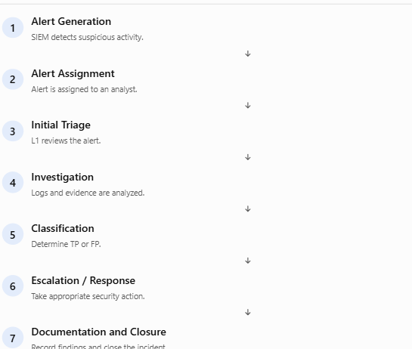

5. Five Important Questions in Alert Triage
Every SOC analyst should answer these five questions when investigating an alert.

Question | Meaning | Example
Who? | Who performed the activity? | User: admin
What? | What happened? | Failed login attempts
When? | When did it happen? | 10:30 AM
Where? | Where did it originate? | IP: 192.168.1.50
Why? | Why is it suspicious? | Multiple failed logins

Example of Triage Documentation
Alert: SSH Brute Force Detection
- Who: Unknown external user.
- What: Multiple failed SSH login attempts.
- When: 10:30 AM.
- Where: Source IP 192.168.1.50.
- Why: Five failed login attempts within five minutes.
- Verdict: True Positive (if investigation confirms malicious activity).
- Next Step: Block the malicious source IP where appropriate, secure the affected account and investigate further.

Importance of SOC
- Provides continuous security monitoring.
- Detects cyberattacks.
- Helps investigate security incidents.
- Protects organizational data.
- Reduces security risks.
- Improves incident response.
Conclusion: SOC teams work together at different levels to monitor systems, investigate threats and protect organizations from cyberattacks.

